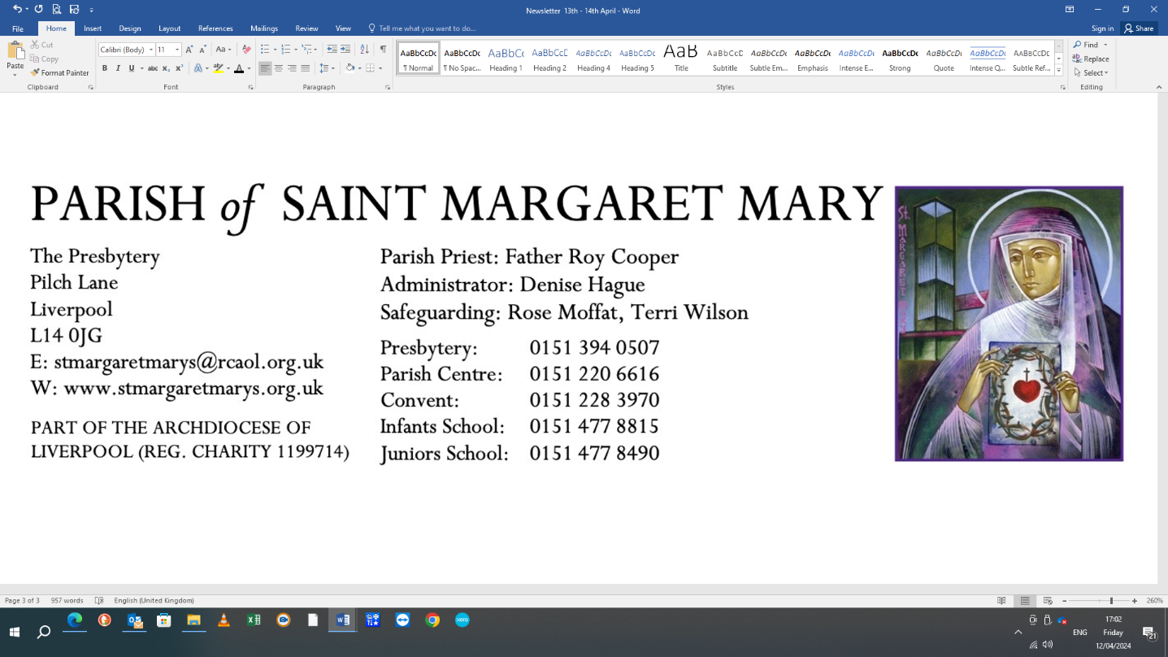6/

|  |  |  |  |  |  |
| --- | --- | --- | --- | --- | --- |
| **LITURGICAL CALENDAR** | | | | Sanctuary Lamp burns for**:** Fr Roy Cooper | |
| Ordinary week 2 -Year C | | | | Our Lady’s Lamp burns for: | |
| DAY | | TIME | SERVICE | | INTENTION |
| Saturday 18th January | | 17:30 | Vigil Mass | | Josie Ferguson |
| Sunday 19th January | | 10:00 | Mass | | Parishioners |
| Tuesday 21st January | | 10:30 | Funeral Service Maureen Davison | |  |
| Wednesday 22nd January | |  | No Mass | |  |
| Thursday 23rd January | |  | No Mass | |  |
| Friday 24thJanuary | |  | No Mass | |  |
| Saturday 25th January | | 17:30 | Sunday Vigil Mass | | Parishioners |
| Sunday 26th January | | 10:00 | Mass | | Fr Roy Cooper |
| Tuesday 28th January | | 18:40 | Evening Prayer Rosary 18:15 | |  |
|  | | 19:00 | Mass | | Siegieniewicz Family |
| Wednesday 29thJanuary | | 10:00 | Mass | | Angela Greenwood |
| Thursday 30th January | | 10:00 | Mass | | Mary Wakeford |
| Friday 31st January | | 10:00 | Mass | | James Burns |
| Saturday 1st February | | 16:30 | Adoration, confession, benediction | |  |
|  | | 17:30 | Sunday Vigil Mass | | Parishioners |
| Sunday 2nd February | | 10:00 | Mass | | Gerard Crooks |
|  | | | | | |
| **PARISH CENTRE CALENDAR** | | | | | |
| DAY | TIME | EVENT | | DETAILS | |
| Thursday | 12:00 | Over 55’s Lunch Club | | Closed for Christmas, resumes 6th Feb 2025 | |
| Thursday | 14:00-16:00 | Knit and Natter Group | | Christmas break, resumes 6th Feb 2025 | |
| Thursday | 19:30 | UCM Meeting | |  | |
| Thursday | 21:30 | Quiz | |  | |
| **Opening Hours**: Thursday – Sunday from 7pm & Sunday afternoons from 12 noon. Mondays – Wednesdays: functions – bar closes at 8pm. For functions, contact Karen, the manager, Tel 0151 220 6616  **Warm and cosy centre:**  Our parish centre is open on Thursdays to all between 1:30-2:30pm, with Free tea, coffee and biscuits, access to TV and WIFI and friendly company. | | | | | |
| **Please pray for the sick*:*** Baby Maher, Brian Peacock, Betty Rawlinson, Gerry Jones, Peter Simpson, Maureen (Mo) Denning, Peter Beswick, Lyn Ashton, Liz North, Joseph Ball, Susan Fade, Gerry Lowe. Maureen Shacklady. Alex Fletcher. John Roberts, John Murphy, Rachel Pickup, Kimberely Lawler. | | | | | |

**N16:1**